*Florida International University*

*School of Computing and Information Sciences*

Feature Document

User Story ID 195

**Team Member(s):** Jordan Laing, Galo Romero

**Project:** Biosensing 2.0

**Product Owner(s)**: Shekhar Bhansali, Yogeswaran Umasankar

**Mentor(s)**: Vishal Chopade, Apurva Sonawane

**Instructor**: Masoud Sadjadi

**User Story:** Write simple android app that connects to BLE device

### **Description:**

* As an admin, I want to be able to connect to the BLE device using a simple Android app.

### **Acceptance Criteria:**

1. Should connect to correct BLE device
2. Should display success (or failure)
3. (Optional) The app successfully displays collected data (temparature, humidity, etc.)

### **Related Tasks:**

Familiarize self with Java APIs for BLE technology.

**Use Case:**

* **I**D: 195-01 - Connect to Device
* **Actor:** User
* **Entry Condition:** This use case starts when the user opens the app.
* **Flow of Events:**
  + The user opens the app.
  + The system displays the status and values of the sensors.
  + The system scans for nearby available SensorTags and connects to the nearest one. [*NoDeviceFound*]
  + The system updates the status and values of the sensors.
* **Exit Condition:** This use case ends when the system updates the status and values of the sensors with real data, or fails to connect to a device.
* **Exceptions**:
  + *NoDeviceFound*: The system was unable to connect to a device and will continue to display null values.

**Use Case Diagram**

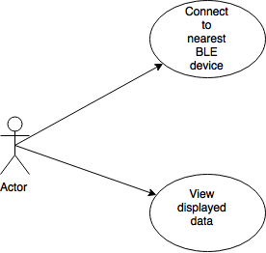

**Sequence Diagram**

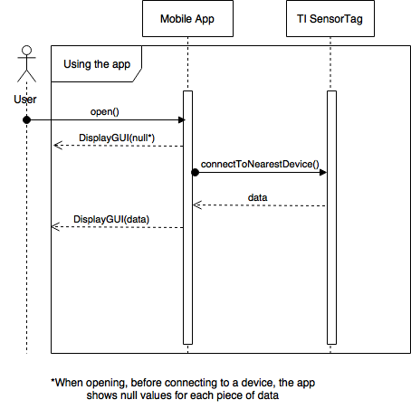

**Testing**

* Test Case ID: 195-001
* Purpose: To test if the mobile app can connect to the SensorTag.
* Preconditions:
  + Evothings Studio installed on computer
  + Evothings Viewer installed on Android mobile device
  + Mobile device has bluetooth capacity and it is enabled
  + TI SensorTag is on
* Expected Result: The app connects to the SensorTag and displays the collected data.
* Actual Result: The app did not connect to the SensorTag.

**User Guide**

In this simple app, the user can take no actions after opening the app, aside from closing it and terminating the program. When opened, the app will display whether or not it is connected to a SensorTag and the value of its sensors, and automatically attempt to connect to the nearest SensorTag. If it does, it will update the display with the current data. The display is shown below.

